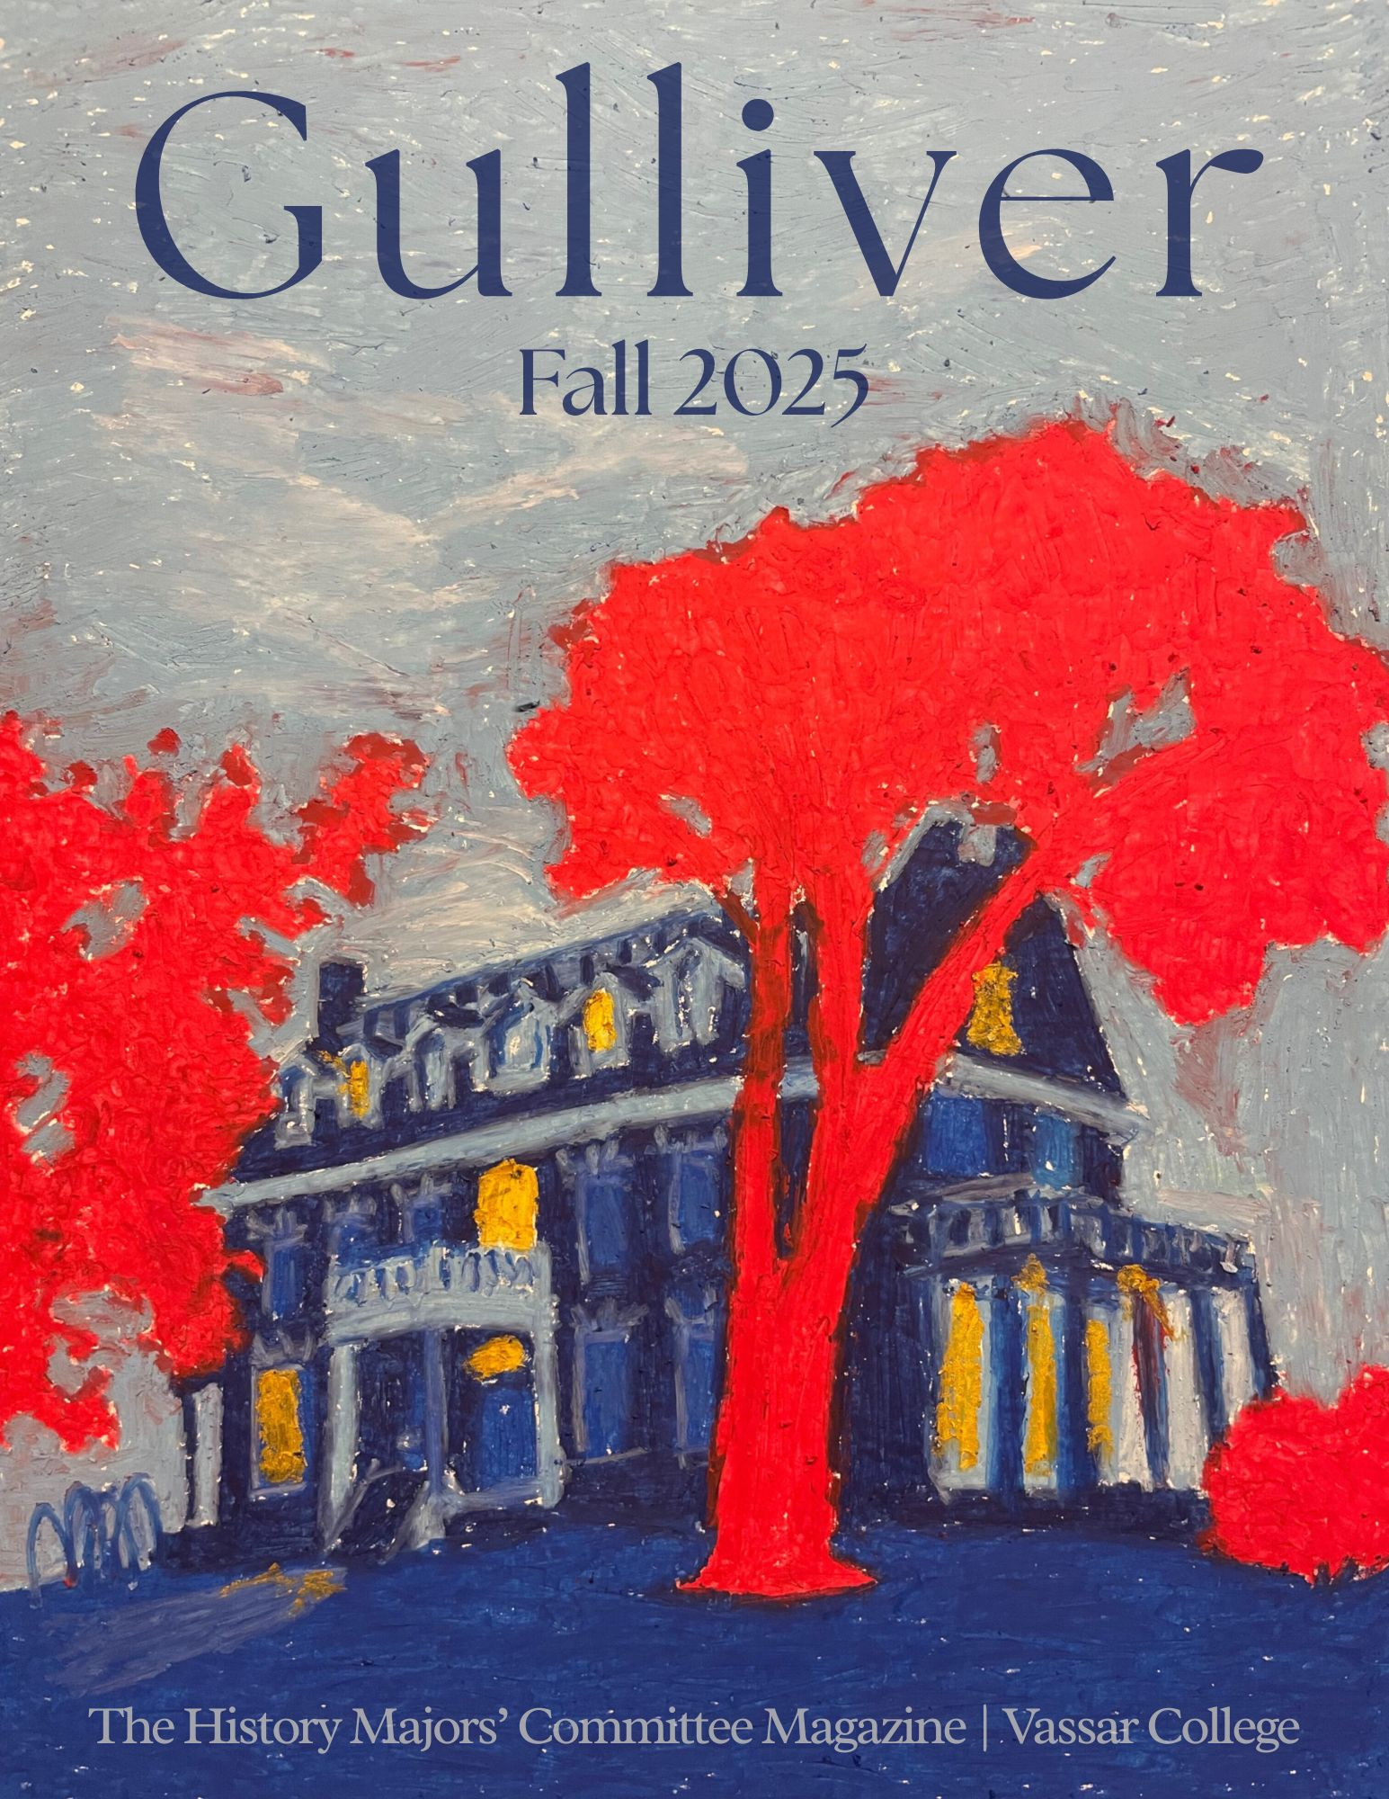

THE FALL 2025 HISTORY MAJORS’ COMMITTEE
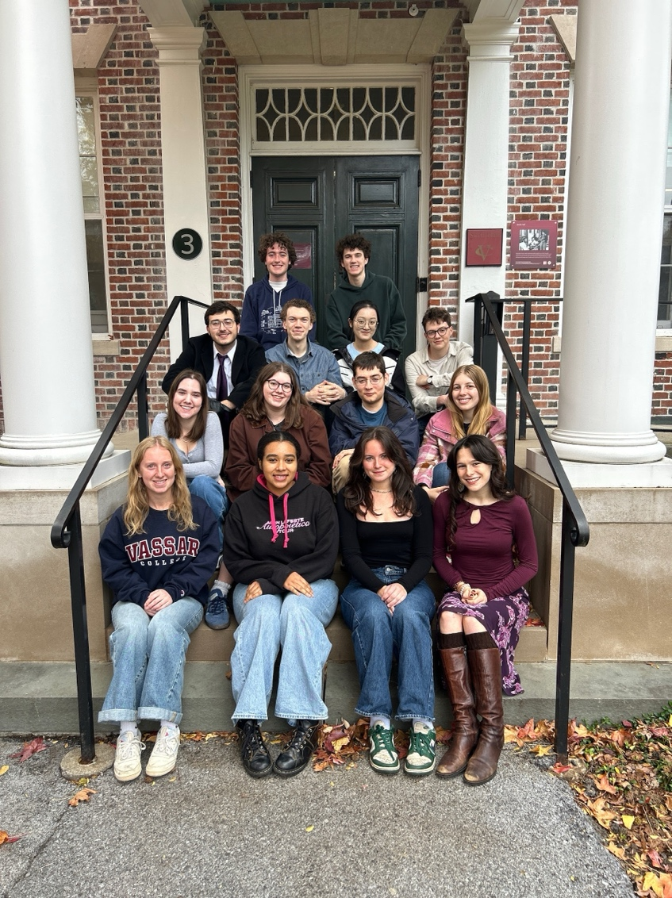
Members (L to R)
Front row: Ava Salvati ‘28, Jazmine Williams ‘26, Willa Jewitt ‘26, Natalie Buzzell ‘26
Second row: Sabina Hawks ‘28, Sara Shepherd ‘26, Ben Savel ‘26, Ella Maurice ‘28
Third row: Bekir Hodzic ‘26, Julian Balsley ‘28, Sirui (Mia) Lyu ‘28, Bodie Morein ‘28
Back row: Peter Adams ‘28, Ben Masur ‘27
Not pictured: Jackson Hrebin ‘28, Sofia Mattos Brito ‘28

Gulliver faculty advisor for Fall ‘25: Professor Lydia Murdoch

Cover illustration by Bodie Morein ‘28
Cover design by Ava Salvati ‘28
Thank you to Sabina Hawks ‘28 for content editing and Julian Balsley ‘28 for layout editing

Table of Contents

Teaching & Researching Hard Histories: A Conversation with Professor AJ Solovy
Bekir Hodzic ‘26
4

Languages of Emancipation and Local Histories: A Conversation with Professor Demetrius Eudell, Historian and Vassar's Dean of Faculty
Peter Adams ‘28 & Ben Savel ‘26
7

Gender and Indigeneity: A Conversation with Professor Noel Smyth
Willa Jewitt ‘26
9

History, Land, and Identity: A Conversation with Professor Ashanti Shih
Sirui (Mia) Lyu ‘28 & Sofia Mattos Brito ‘28
11

Historical Reflections on the Viet Nam War: A Roundtable Discussion on the Impact of Professor Robert Brigham’s Viet Nam War Class and Conference
Jackson Hrebin ‘28, Ben Masur ‘27, Ella Maurice ‘28, Bodie Morein ‘28, and Ava Salvati ‘28
14

Seeing a City Through Its Library: My Work with a Portland Oral History Project
Julian Balsley ‘28
18

Mid-Hudson Anti-Slavery History Project Internship: Local Public History
Jazmine Williams ‘26
20

From Handkerchiefs to Hoop Skirts: My Experience Working With Historic Textiles at Locust Grove Estate
Sara Shepherd ‘26
21

Semester in Photos
Designed by Natalie Buzzell ‘26
23

Spring 2025 History Department Courses
24

Teaching & Researching Hard Histories: A Conversation with Professor AJ Solovy
Bekir Hodzic ‘26

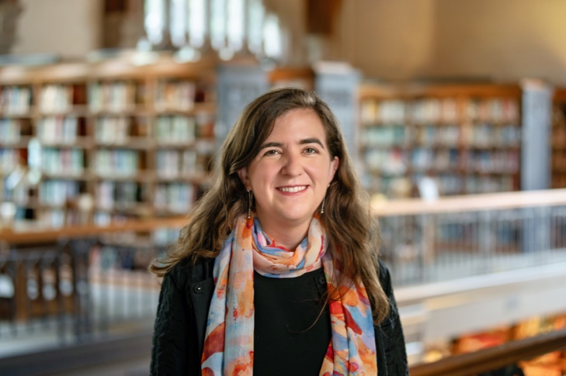
Copyright Karl Rabe/Vassar College.

How do we both teach and learn about difficult histories, particularly those rooted in mass violence, ideological extremism, and genocide? And what are the ethics of research in these fields? As a history student, those questions have animated much of the academic and professional work I have pursued at Vassar. Thus, I was thrilled to interview Professor AJ Solovy, the Vassar History Department’s newest hire, about her work as a historian of modern Central Europe. I sat down with Professor Solovy to discuss her research, academic interests, and pedagogy vis-á-vis teaching about the Holocaust.

Professor Solovy’s path to Vassar started when she was young. As she mentioned, “I have wanted to study history since I was about eight years old.” That interest arose from her realization as a child that everything about the world she lived in could only be explained and understood by looking to the past. That sense remained with her throughout her life, leading into her undergraduate years at Williams College, another liberal arts institution, during which she focused on studying history. While at Williams, Professor Solovy experimented by taking courses across different historical subject areas, but upon entering classes with two professors who worked on the histories of modern Europe, the Holocaust, and Nazism, she found that they raised important questions about modernity, queries she wanted to explore further.

Alongside her college experience, her personal background fed her interest in those areas. Professor Solovy explained that “I do have a familial connection to this history and I grew up hearing stories about my great-grandparents’ experiences in Central and Eastern Europe. Mass violence, persecution, and discrimination were issues that always seemed important to me.” Yet despite that linkage, she also held a more abstract fascination with these topics; the events of World War II were, for her, “beyond the conceivable. The scale of violence, the scale of destruction didn’t make sense.” In other words, they presented a critical intellectual challenge to approach as well. Professor Solovy accordingly followed that interest past her bachelor’s degree in history at Williams, getting a master’s from the University of Vienna in contemporary history [Zeitgeschichte], before then completing her history PhD at the University of California, Berkeley.

Her time at Berkeley helped concretize her academic focuses. There, Professor Solovy centered her studies on the history of West Germany and Austria after World War II, drawing from wider histories of Europe, Jewish studies, and microstudies of local communities. These emphases eventually birthed her dissertation—now being worked into a book project—which, broadly, “is about the place of fascist ideologies, fascists, societies, and fascist cultures in postwar liberal democracies.” More specifically, it looks at the “lives of former members of the SS in West Germany and Austria from 1945 through approximately the 1990s,” contemplating, among other things, their organization into civic associations and relationship with neo-Nazis, to consider “what does it mean when you have former Nazis, who describe themselves as such, reorganizing in democratic society.”

Asked about how she approached engaging with these Nazi materials historically, Professor Solovy replied: “People say this about all of their books, and I think this is true. You write the book and then there’s the story about how you researched the book. That could be a separate book.” She discussed how, while she accessed many sources via archival repositories, she additionally needed to face the complex intergenerational politics that emerged within post-Nazi societies. This meant hearing from and gathering records from the children of former Nazis, some of whom were immensely angry about their parents’ pasts and some of whom were proud of them. All these involvements helped Professor Solovy think not just about what the sources she was working with said, but where they came from and the stories behind their provenance, which, to her, held just as much historical significance. And in dealing with the repugnant beliefs she often confronted in this work, she sought to keep asking “why?” to drive herself forward and better situate what she witnessed in its larger context.

Of course, with any perpetrators of mass violence come those targeted by their brutality. In line with that important fact, Professor Solovy underscored how she incorporated encounters between former Nazis and Holocaust survivors into her scholarship, dealing with not only how these moments raised key questions about the Holocaust’s aftermath, but how “survivors used these encounters to better understand the choices they made in the past and in their lives in the present.” Indeed, interrogating such exchanges aids her as she thinks about her own teaching. Professor Solovy highlighted how she is invested in “having her students grapple with how distinct experiences and understandings of historical events can be analyzed from several perspectives,” plus “to investigate how we fit these seemingly discordant stories together in order to craft a coherent narrative of a given historical period.” This centering of a plurality of perspectives feeds into her view of the classroom as an “exciting and very creative space,” where she wants to both hear from as many people as possible and allow students to experiment with ideas.

Professor Solovy, however, further stressed that she believes a distinct set of ethical inquiries needs to accompany any scholarly consideration of events like the Holocaust and genocide generally. From the first day of many of her classes, she asks students to begin pondering what it means to tackle emotionally-laden topics like violence intellectually, and to consistently reflect on the “question of how we can know what happened and how we should, or can, study what happened.” She encourages students to “notice their own reactions and bring them into the classroom, because those are telling experiences.” Said otherwise, she places an “emphasis on human experience” in her pedagogy.

On that note, Professor Solovy spotlighted some of the classes she is currently teaching at Vassar and what courses she hopes to teach soon. This fall, she is running HIST 223: “History of the Holocaust” and HIST 112: “Modern European History.” Next semester, she plans to teach HIST 360: “Fascism in Twentieth Century Europe” and HIST 234: “Fin-de-Siècle Vienna: Crisis, Politics, and Culture in a Modern City.” The latter course will build off of Professor Solovy’s interest in microhistory and using ordinary life as a theater to explore historical processes, continuities, and contingencies. She aims to offer an intensive next year on the “Origins of Totalitarianism,” where students will read Hannah Arendt’s work of the same title. While she also hopes to someday conduct a class on postwar democracies in Europe and a survey on modern Germany, a dream class she would love to teach would be one on the history of cultures of death in Europe during the modern period, where students would examine memory and memorialization as they have been erected across time on the continent.

To conclude, Professor Solovy raised two works she recommends Vassar students read as they embark on studying history: Reinhart Koselleck’s “The Practice of Conceptual History: Timing History, Spacing Concepts,” and “Critique and Crisis: Enlightenment and the Pathogenesis of Modern Society.” Both writings reckon with “how we understand history, offering a novel theory of history’s direction and design. They also powerfully convey ways in which history can make our own contemporary world a little bit more legible,” or, as some might say, the heart of history as a discipline.

Languages of Emancipation and Local Histories: A Conversation with Professor Demetrius Eudell, Historian and Vassar's Dean of Faculty
Peter Adams ‘28 & Ben Savel ‘26

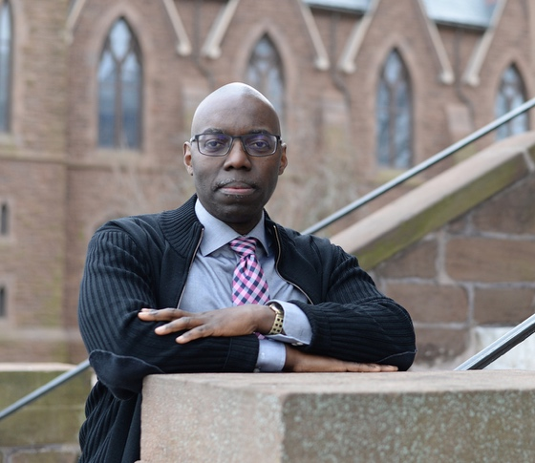
Copyright Vassar College.

Academic Background
We recently interviewed Demetrius Eudell, History Professor and recently appointed Dean of Faculty, to discuss his work in studying Black history in the US and the Americas and his own history as an academic and educator. Dean Eudell joined Vassar in July 2025, having previously served as the Vice President for Academic Affairs at the Cooper Union for the Advancement of Science and Art. Before his time at Cooper Union, Dean Eudell served as the Dean of Social Sciences and Professor of History at Wesleyan University for more than 20 years. He earned his Doctor of Philosophy in US History from Stanford University in 1997.

During his time at Wesleyan University, Dean Eudell offered courses on intellectual, Black, and US history, and he was awarded the Binswanger Prize for Excellence in Teaching by Wesleyan in 2016. In addition to his role as Vassar's Dean of Faculty, Eudell also serves as Professor of History.

Black US History
We asked Professor Eudell about his book, The Political Languages of Emancipation in the British Caribbean and the U.S. South, which was published in 2002. Part of the reason why slavery in the United States was so difficult to abolish, he described, is because of how entrenched the system—and language—of hereditary, racialized slavery was. Competing discourses of liberalism emerged that simultaneously embraced antislavery but also anti-Blackness, including from Oliver Howard, the namesake of Howard University, or members of the American Colonization Society, who could only envision Black emancipation taking place in Liberia, outside of the United States. As a result, abolitionist thinkers, such as Richard Allen of the African Methodist Episcopal Church in Philadelphia and Frederick Douglass, had to engage in an intensely difficult process of linguistic and social transformation to help envision an abolitionist future.

His book describes a similar process that took place in Jamaica. In early Jamaican historiography, there was a popular “flight from the estates” thesis in Jamaica, an idea that slaves fled plantations because they had so much trauma that they would not want to stay on the plantation. Arguing against this thesis, he pointed out that, for instance, at the Playfield plantation, the enslaved had built the plantation and wanted to keep living there, maintaining their connections to the land, but being paid for their labor. He summarized that societal change can be extraordinarily difficult because of how deep-rooted mental concepts tend to be.

Carceral CT and Teaching
Despite the fact that he will not be teaching any Vassar History courses in the near future, Dean Eudell described himself as “the perennial student.” He spoke highly of the “cultural intellectual life” of scholars and students at small liberal arts colleges like Vassar.

In addition to serving as the Dean of Faculty, Dean Eudell is also the principal investigator of the Carceral Connecticut Project, an interdisciplinary exploration of slavery, race, industrialization, and their ties to Connecticut’s history of incarceration. The Carceral Connecticut Project, funded by the Mellon Foundation’s “Humanities for All Times” initiative, focuses on industrial and regional history, law and social justice, and the history of policing in Connecticut.
Dean Eudell described the multi-layered way in which the project defines incarceration, both in terms of imprisonment and, more broadly, as social and institutional restrictions on people’s lives and opportunities, such as their housing and education.

The achievements of the Carceral Connecticut Project include a 2024 conference at Wesleyan University titled “Remembering the Black Panthers in New Haven”; a documentary film on the history of the insurance industry and the concept of risk titled “Futureproof”; and a collaboration with the Middlesex County Historical Society (MCHS) in staging a future exhibition on the history of Middletown’s historically Black, now demolished, South End neighborhood titled “Re-Making Middletown: Race and Redevelopment in Mid-20th-Century New England.”

One of Dean Eudell’s primary contributions to the Carceral Connecticut Project has been his supervision of the research on the fifty-year consent decree, which placed the Hartford Police Department (HPD) under judicial oversight from 1973 to 2023. The decree, known as Cintron v. Vaughn, began in 1969 as a class action lawsuit against the HPD and the Hartford city government by victims of police brutality. The research into Cintron examines the history of police reform from “within the system” by analyzing the history of policy-community relations and community efforts to hold institutions of Hartford accountable.

We enthusiastically welcome Dean Eudell to Vassar’s History Department and look forward to seeing his future research. Dean Eudell will not be teaching courses in the History Department this year, but we hope to see him in the classroom in the near future.

Gender and Indigeneity: A Conversation with Professor Noel Smyth
Willa Jewitt ‘26

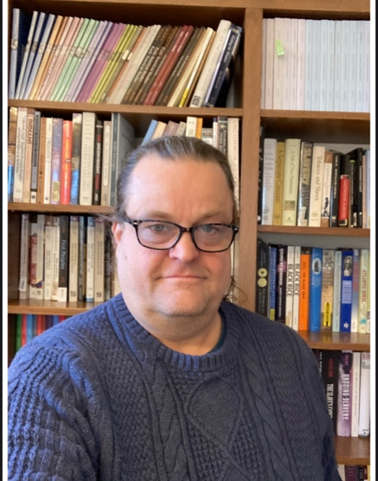
Photo courtesy of Noel Smyth.

There are two premier fellowships for Early American scholarship: the McNeil Center at the University of Pennsylvania and the Omohundro Institute at the College of William and Mary. In 2023, History Professor Noel Smyth received a postdoctoral fellowship at the Omohundro Institute to continue his research on the history and present-day life of Natchez communities in the southeastern United States. I sat down with him recently to talk about his experience with the Omohundro, and he emphasized how this fellowship opportunity enabled him to refine the manuscript for his upcoming book.

When he started this project, he planned to write a book about Natchez-French contact after 1731, which is when the French violently attacked and enslaved hundreds of Natchez families, forcing them out of their homelands. However, over the course of his research, this project turned into two books.
Rather than exploring pre-French contact in one chapter of a book, Smyth decided to write another manuscript about this period. In this second book, Smyth plans to “build some sort of groundwork on how gender operates in Natchez communities” because there is a lack of scholarship on Natchez women. Focusing on the earlier period allows him to write about Natchez kinship structures in a way that centers the role of women. He says, “there needs to be a better book about Natchez-French contact… and I want women to be part of the story.” Professor Symth deviates from scholarship that limits its analysis to comparisons between Natchez communities and European ideas of hierarchy and patriarchy, focusing instead on how Natchez structures functioned outside of these colonial structures. He emphasizes Natchez women’s experiences of sexual violence and work as translators as two ways of exploring Natchez’s women’s actions and agency. Smyth imagines this book as a “short, narrative piece,” and wants to “shift the narrative structure to reflect the Natchez perspective.”

Smyth’s work also incorporates oral histories. He works with Hutke Fields, the current chief and Great Son of the Natchez, to learn more about the Natchez perspective. There is no scholarship that includes Natchez commentary on the history of Natchez-French contact, and Smyth considers this to be an essential part of his book. Smyth’s work places an emphasis on contemporary Natchez communities, and examines how these communities view their history, allowing us to trace how narratives of resilience are passed down through generations.

The Omohundro Institute also gave Smyth the opportunity to work with book editors and publishers. He emphasized how helpful the institute was when it came to book proposals and the process of publishing a book. The work Smyth did through the fellowship also translates into the courses he is developing for the History Department at Vassar. In Spring 2026 he is offering a new class called “Indigeneity, Race, and Gender in the Native American South.” This class will focus on Native American history in the South, with an emphasis on Afro-Indigenous history and the petites nations in Louisiana. These culturally and linguistically diverse groups lived in close proximity, and the class will focus on interactions among them. The course will be “centered on Native peoples and particularly their relationships with other people of color.” Smyth put many Native scholars on the syllabus, allowing their voices to guide this history and students’ learning experience.

History, Land, and Identity: A Conversation with Professor Ashanti Shih
Sirui (Mia) Lyu ‘28 & Sofia Mattos Brito ‘28

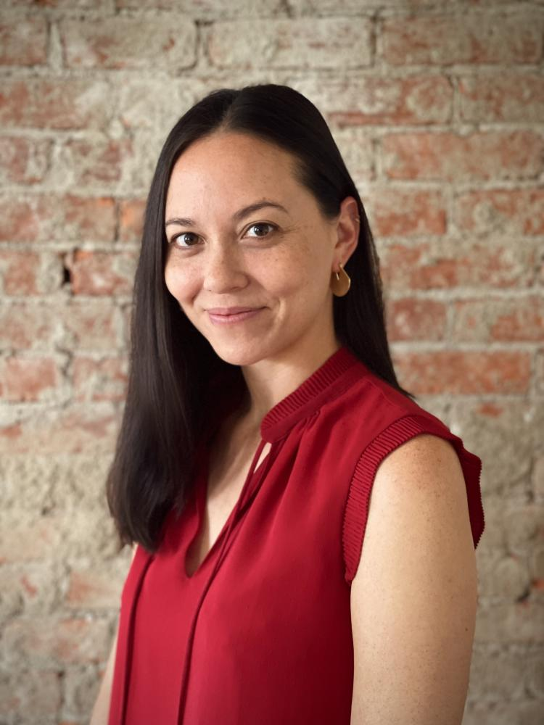
Copyright Vassar College.

Earlier this semester, we sat down with Professor Ashanti Shih, Assistant Professor of History, who recently came back from leave. Her work centers on Asian American history, Native Pacific and Indigenous studies, environmental history, and the history of colonial science. We talked to Professor Shih about her current book project and her areas of interest.

The book project that Professor Shih worked on during her time on leave is about the history of the National Park Service in Hawaii, which evolved from her dissertation. Professor Shih mentioned that the main argument of her book revolves around how the government uses “the national park as the natural laboratory to continually take land from Native Hawaiians and also prohibit them from gathering and hunting.”

Professor Shih explained that she chose this topic “partly from personal interests and partly from an archival accident.” Growing up in Hawaii, she always went to national parks during her childhood. She also mentioned that her dad is a geologist, so she was always around people in the environmental studies field. All of these factors spurred her early interest in and awareness of environmental topics. As for the archival accident, she said her original idea for her dissertation was on the papaya industry in Hawaii. Therefore, she went to Hawaii and examined archival records related to the papaya industry; unfortunately, she found that this topic was not as fruitful as she had hoped. Then she decided to visit the national park to see whether she could discover a topic worth researching. This time she was immediately fascinated by everything she observed in the archive. For instance, she noticed conflicts between scientists and hunters concerning goats in Hawaii. She explained that the scientists wanted to kill the goats to help plants grow, but the hunters wanted to kill the goats for recreation, leading to tensions. She explained that all these different perspectives about animals, plants, and land management intrigued her deeply. In addition, the topic of national parks, with more case studies she could draw out, brought together her interests in people, environmental issues, and conflicting perspectives. As a result, she made the decision to write her dissertation on national parks in Hawaii.
There were two particular challenges she faced during her research. The first was Covid, which made it difficult for her to fly to Hawaii to do research there. The second challenge was that she did not have training in reading Native Hawaiian language. Thus, in order to read the rich archival sources, such as the Native Hawaiian newspaper, she had to learn the language alongside researching. “It’s difficult to learn a new language totally by yourself,” Professor Shih said.

Until now, we had spoken a lot about her research regarding Native Hawaiians; however, all the courses she currently offers center around Asian American history. We asked her how she saw the relationship between Native Hawaiians and Asian Americans. She said before picking her dissertation topic, she was more focused on Asian American history, so teaching in this area is kind of “returning to my original interest.” Furthermore, she thinks that because Asian Americans occupy the majority of population in Hawaii, “it’s really natural if you know about Hawaii, or the Pacific more generally, to study both Asian American histories and Native Pacific studies.” Moreover, she emphasized that because she is the first tenure-track professor of Asian American history at Vassar, she feels the duty to design more courses regarding the Asian American experience.

Professor Shih is thrilled to be back on Vassar’s campus this semester and is especially eager to continue teaching from Asian perspectives. “I want to show students what studying topics from an Asian perspective actually brings and transforms,” she explained as the goal for next semester.

This spring, she will be offering her recurring “Chinatowns” class (HIST-227) and an “Asia in the World” intensive (ASIA-194) focusing on tourism in Asia. Professor Shih described to us the personal connection she has to one of her classes. The “Chinatowns” class was based on an article she had written about Chinatowns in Los Angeles, but more importantly, she shared that her own father grew up in New York City’s Chinatown. Subsequently, she always felt a desire to learn more about this subdivision of Asian American history, especially as this linked her to the eastern part of the United States, which she is more unfamiliar with.

Additionally, her “History of Asian American Social Movements” course (HIST-314) will once again integrate Asian perspectives, challenging the pervasive stereotype of passivity that is often associated with Asian communities. “In reality, there is a really rich history of protest and resistance, and organized movements and disorganized movements.”

When we asked Professor Shih what she loves about teaching at Vassar, she stated “that every semester or every time that someone writes a research paper,” she learns something new. She is constantly surprised and intrigued by how even a writing prompt can often incentivize creativity in Vassar students.

When we asked Professor Shih if she had any book recommendations for students who are interested in learning more about Asian American history, she recommended The Making of Asian America by Erika Lee. While not on all of her class reading lists, she says the book can provide an exhaustive overview in a way that is relatively new to the study of Asian history.

Historical Reflections on the Viet Nam War: A Roundtable Discussion on the Impact of Professor Robert Brigham’s Viet Nam War Class and Conference
Jackson Hrebin ‘28, Ben Masur ‘27, Ella Maurice ‘28, Bodie Morein ‘28, and Ava Salvati ‘28

Throughout the Spring 2025 semester, Vassar’s Shirley Ecker Boskey Professor of History and International Studies Robert K. Brigham taught a comprehensive class about the Viet Nam War. Nearly fifty students were enrolled in the course, and Vassar students not enrolled in the course, as well as faculty, alumni, and scholars from other colleges, often sat in on and contributed to Professor Brigham’s class. On a few occasions, leading scholars and authors delivered lectures to the class. Colonel Gregory Daddis, a History professor at Texas A&M University, lectured students about the failures of American military strategy. Jack McLean, Viet Nam War veteran and author of Loon: A Marine Story, shared his personal experiences with and interpretations of the war. Associate History Professor at Dartmouth College Edward Miller challenged students to think critically about the viability of South Viet Nam prior to the outbreak of war. Students were assigned readings by these guest speakers so they could discuss sources directly with their authors.

The class received widespread attention in part due to Professor Brigham’s forthcoming memoir, This Is a True War Story: My Improbable History with Vietnam. Actress, filmmaker, and Vassar alumna Alexa Alemanni currently has the film rights to Professor Brigham’s story and is in the process of pitching it to studios. On a few occasions, television and film crews came to

film class sessions for these upcoming productions.

On the weekend of April 30th, 2025, Professor Brigham hosted an academic conference at the Vassar Institute for the Liberal Arts titled “Remembering the American War in Vietnam: A 50-Year Retrospective,” commemorating the end of the Viet Nam War. The conference took place on the 50th anniversary of the end of the war, and brought together leading Viet Nam War scholars, including journalists, authors, and veterans. All students enrolled in Professor Brigham’s course were invited and encouraged to attend.

Among the panelists who attended were Beth Bailey, a professor and the Director of the Center for Military, War, and Society Studies at the University of Kansas. Bailey delivered a presentation about the US army’s history of racial discrimination and legacy of injustice. Kara Dixon Vuic, a Professor of War, Conflict, and Society in Twentieth-Century America from Texas-Christian University spoke about the complex roles that American women served during the war. Gregory Daddis returned to deliver a presentation about the failures of communication between high command, the rest of the military, and the public. Peter Osnos, a publisher and former foreign and national editor for The Washington Post, and James Sterba, a former foreign, war, and national correspondent for The New York Times and The Wall Street Journal, shared their insights into how journalism impacted the war. Also speaking were Ron Milam, a Viet Nam veteran and Professor of History at Texas Tech University; Jim Willbanks, a former General of the Army, author, and military historian; and David Kieran, a Distinguished Chair in Military History at Columbus State University. Fred Logevall, the Laurence D. Belfer Professor of International Affairs and Professor of History at Harvard University, served as the keynote speaker. Throughout the weekend, all of the invited speakers gave presentations about their research and published works. These scholars also spoke directly with students about the war and its connections to the current state of American politics. Below are several perspectives from students who were enrolled in Professor Brigham's class and attended the conference.

Ben Masur ‘27
The relaxed atmosphere of the conference allowed for intimate, one-on-one interactions with some of the country's foremost experts on the Viet Nam War. Beginning with the opening reception, an hour of mingling around the Vassar Institute for the Liberal Arts, chatting with students, alumni, and historians, and munching on hors d’oeuvres, I was able to have interesting conversations, both on the Viet Nam War and unrelated topics. I met Professor Fred Logevall, who won a Pulitzer Prize for his book Embers of War: The Fall of an Empire and the Making of America’s Vietnam. After making small talk for a few minutes, I grew confident enough to discuss my research paper from Professor Brigham’s course. I was looking at how President Lyndon B. Johnson’s emotions, notably his arrogance, toxic masculinity, and self-consciousness, affected his Viet Nam War foreign policy. Professor Logevall was thrilled to discuss such a topic with me, and, in his slight Swedish accent, enthusiastically recommended several pieces of scholarship on President Johnson, and even a few primary sources. Professor Logevall’s kindness and intelligence really stood out to me, as he was by no means obligated to give me such good advice and help. I ended up using several of the sources he recommended to me in my final paper.

Jackson Hrebin ‘28
When I arrived at the conference I was immediately struck by the amount of people in attendance. The institute was packed with students, professors, and scholars. Very rarely have I been in a room with so many experts. Having spent an entire semester learning about the Viet Nam War, and in some cases learning about the academics who attended the conference, it was simultaneously thrilling and intimidating to be in their presence. Peter Osnos, a publicist and former editor for The Washington Post, quickly roped me and a few other students into a conversation. Osnos asked us about our opinion on topical political issues and encouraged us to share our thoughts about leaders we admired. Several of us mentioned Pete Buttigieg and Bernie Sanders, but we all noted that we felt there was an absence of inspiring leadership at the time. In contrast, Osnos recalled the excitement he felt during Bobby Kennedy’s 1968 presidential campaign. Osnos also discussed the current Trump administration, and asked us to consider how its actions parallel the political decisions that contributed to the Viet Nam War. It was amazing getting to hear his insights, but even more empowering to know that he cared about what I thought. Speaking with Osnos, along with other scholars made me appreciate my place in history and helped me recognize the impact young people and students like myself can have on the future.

Ella Maurice ‘28
In my entire life, I think I have only met the authors of books I have read twice, and both times were while I was in Professor Brigham’s Viet Nam War class. One of these instances was at the 50th Anniversary Conference at the end of the year. Professor Brigham had given me Beth Bailey’s book, An Army Afire, to use for my research paper on Black Americans’ reactions to the inequities of the Viet Nam War draft. Professor Bailey gave a talk at the conference and I jumped at the opportunity to hear her speak about her research, which had been so instrumental to my journey of understanding the background of my research topic. Attending the conference was my first exposure to the wider history community outside of Vassar and I am so grateful that I had the opportunity in my first year of college. It was inspiring to see people so willing to share their research and interests with those around them.

Bodie Morein ‘28
The whole conference felt warm and very down to earth. I assumed beforehand that the scholars would mostly speak amongst themselves, and that the conference would be separated into groups of students and panelists. Instead, as early as the Friday evening reception, Peter Osnos drew me and a group of other students into a circle and asked us our thoughts on current politics and if there were any public figures we admired. I was struck by how much he wanted to know; he was not humoring us, but really was curious about what we had to say. This, to me, was indicative of the rest of the conference. I spoke to a few more panelists, including Ron Milam and Fred Logevall, both of whom were very happy to talk. They didn’t see it as an imposition, but rather welcomed my questions enthusiastically. During the panels, the participants spoke among themselves with humor, and between events continued to converse, both about their areas of study and also beyond. I left the conference feeling buoyant, and sure that this academic world was one I wanted to inhabit.

Ava Salvati ‘28
This conference was an eye-opening look into modern warfare studies and the research that goes into answering questions which are still highly debated in the academic world. Jim Willbanks, a professor, author, and Viet Nam veteran shared his war story, offering a fascinating account of his experience as an infantry advisor. Peter Osnos, journalist and former editor of the Washington Post, introduced noteworthy ideas about the role of the media during the war, which still stands as a widely debated topic. I found Peter Osnos’ and Jim Willbanks’ accounts to be particularly remarkable, seeing as my final research paper for Professor Brigham’s class dealt with the role of the media in deciding the war, specifically at the time of Willbanks’ service. It was incredible to see the topics I researched come to life through the voices of these brilliant speakers. I was introduced to ideas and questions I had never thought of before, which only furthered my interest in warfare studies. Furthermore, Professor Brigham’s personal narrative of finding his biological father never fails to inspire an audience, and it was incredible to watch someone speak with so much passion and love for what they do. This conference offered a multitude of new perspectives and ideas that could do no less than electrify an audience of curious students, researchers, and academics.

Seeing a City Through Its Library: My Work with a Portland Oral History Project
Julian Balsley ‘28

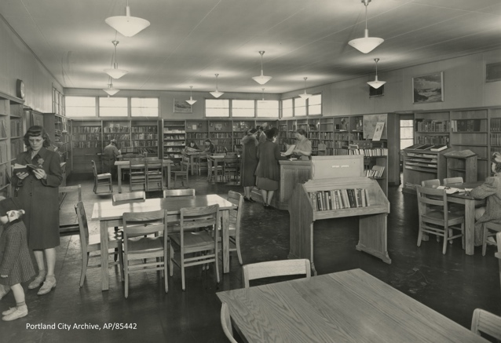
Photo courtesy of Portland City Archives.

Last summer, I interned at a small oral history project about a ten-minute bike ride from my house in northeast Portland, Oregon, called Vanport Mosaic. Started a decade ago by journalist Laura Lo Forti and activist Damaris Webb, the project was meant to be a one-off series of oral histories with survivors of the Vanport, Oregon, flood of 1948. It has since grown into a project of oral histories, exhibits, and a multi-week annual festival on the history of Vanport and Japanese internment in Oregon.

Vanport was a federal housing project established during World War II to house workers from the shipyards on both sides of the Columbia River, which separates Washington and Oregon. The town was named after the two cities it sat between—Vancouver, Washington, and Portland, Oregon. Vanport quickly grew in population and diversity as men and women, from every state in the Union and multiple countries, flocked to the shipyard jobs; the Great Migration was in full swing and many Black families moved to Vanport, where the housing was segregated but the public facilities were not. Vanport soon became Oregon’s second-largest, and most diverse, city.

When I started at Vanport Mosaic in late May, Greta, one of the organization’s historians, asked me to go through a collection of reports on the Vanport Public Library (VPL) that they had received a few years ago from the local county archive. I said yes on the spot. It became my entire summer.

The VPL, opened in August 1943, was the only public library in a federal housing project and was given a central location on the main street, Victory Boulevard, in Vanport’s original construction plans. The reports were written by the librarian, Eleanor Touhey, and her replacement, Elizabeth Weed. Because the Central Library required all of its branches to submit monthly reports, which were housed in downtown Portland, the VPL’s first-person history survived the 1948 flood, unlike the majority of Vanport documents.

The reports show us the daily movements of Vanport life, from book requests for Freud to a young Black woman teaching herself and her husband to read and write. For my project, I read over 50 reports, scoured digital archives of local papers, and pored over local archives’ manila folders packed with newspaper clippings and government documents. I emerged at the end of the summer with, to my knowledge, the most expertise on the Vanport Public Library of any living person.
The library and its staff were a central part of Vanport’s public life. The reports are full of accounts of people discussing how much they love the library and how many took advantage of the resource, especially Black Vanporters. The reports describe many people for whom VPL was their first public library—the first time they could read thousands of books for free and ask for more. Black patrons frequently requested books on “the race problem,” and reports note that despite buying as many books on the subject as possible, the library could never meet demand. In one report, the librarian wrote that Black patrons were “among our best readers” and that librarians’ thinking on race in the United States was frequently expanded through conversations with Black patrons.

The library’s importance to so many Vanporters also reveals the hard life of the city. Residents who expressed love for the library often said that without it, life in Vanport would be unbearable. The shipyard ran 24 hours a day and the walls of the hastily constructed housing were thin. Street fights were common. Vanport was no paradise of diversity and ample public services. It was a hard-working city in which a small public library was one of the few respites from a difficult, lonely life of grueling work and yearning for the people and places left behind in search of a better life. Those who landed in Vanport found steady work as long as the war continued, but they also found many struggles. A library being the only thing stopping life from being unendurable does not speak well to a city’s standard of living.

Despite my work with Vanport Mosaic, I am not an Americanist. At Vassar, I am focusing my history degree on modern Middle Eastern history, especially Palestine and Morocco. But studying Vanport brought me closer to the city where I was born and raised, and brought me new interest in Black US history. Over the summer, to supplement my research, I read books on the Portland chapter of the Black Panthers, how the federal government segregated US housing, and Bryan Stevenson’s Just Mercy, a memoir of fighting racist incarceration in the South. The underlying themes of my work on Vanport, however, were not far from what I do in Middle Eastern history. Like the United States, so much of Middle Eastern historiography has been filtered through the oppressor, largely obscuring the lives of the people being oppressed and fighting oppression. My work with Vanport brought me close to the people who lived in Vanport before their community was wiped out in a single afternoon—I read words they had spoken only a short drive from my home, heard about what books they liked to read and how they felt about living in Vanport. Although geographically distant from the Middle East, studying Vanport and its people was another strand in the larger mission I pursue in the Vassar History Department.

Mid-Hudson Anti-Slavery History Project Internship: Local Public History
Jazmine Williams ‘26

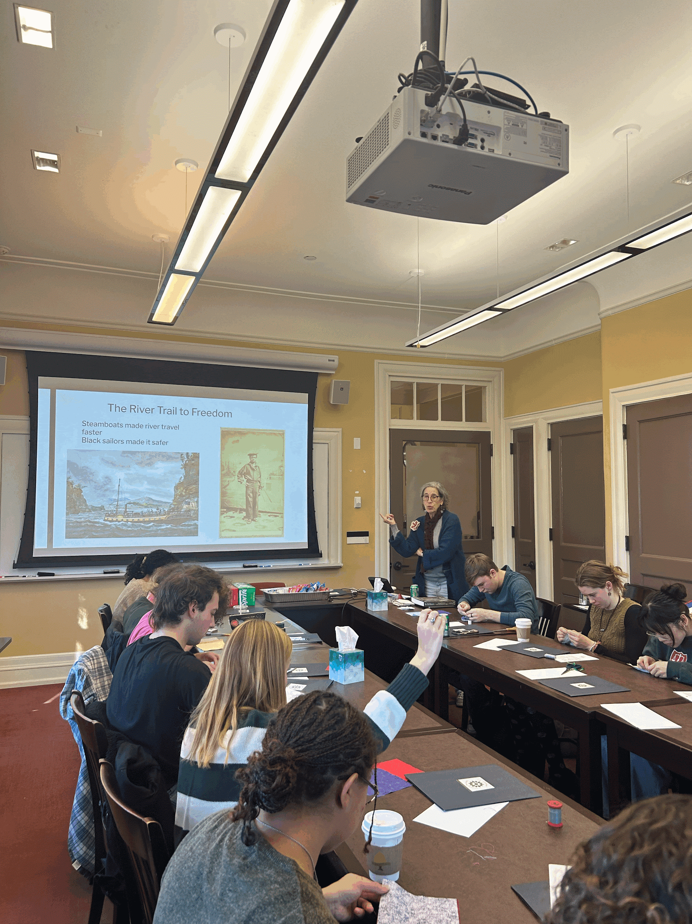
Vassar Fall 2024 Quilting Circle, photos courtesy of Jazmine Williams.

One of the experiences that I will carry with me the most from my time at Vassar will be my work with the Mid-Hudson Anti-Slavery History Project (MHAHP) and one of its signature programs, the Oh! Freedom Quilting Project. MHAHP is dedicated to uncovering the history of slavery and abolitionist efforts in the Hudson Valley. They center their research on local abolitionists and sites in
Poughkeepsie, ultimately seeking to make history accessible. The part of this organization's work that resonates most with me is the Oh! Freedom Quilting Project. This project takes the research work from MHAHP and presents it to various community quilting circles. After, they ask each participant to take an aspect of the history that stood out to them and create a quilt square. The squares then get put together into a community quilt that becomes a part of a growing archive.

In the almost two years that I have worked with the MHAHP, I have learned how history can be applied outside of the classroom through presenting research to community members of all ages. I have been able to assist in quilting circles with local students and even led one at Vassar in the fall of 2024. I have helped put together artist statements and quilt displays. I have also been able to engage with spaces in the Poughkeepsie area such as the First Congregational Church, a historically abolitionist church. MHAHP is fundamentally a community-run organization, and in conversations with their members I have begun to appreciate the ways in which a history can shape people’s experience of a place and display its significance. Through my work with MHAHP I have gained an appreciation for Poughkeepsie and the work being done to engage the community with local history.

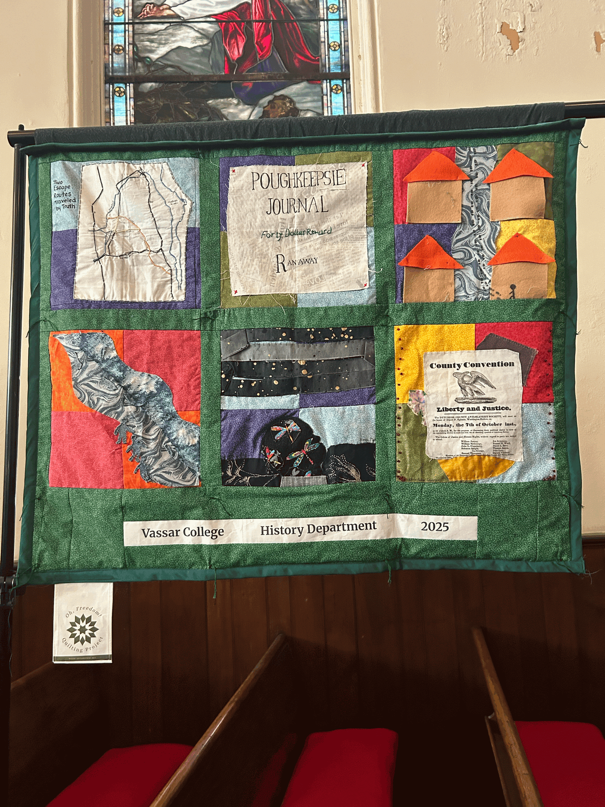

From Handkerchiefs to Hoop Skirts: My Experience Working With Historic Textiles at Locust Grove Estate
Sara Shepherd ‘26

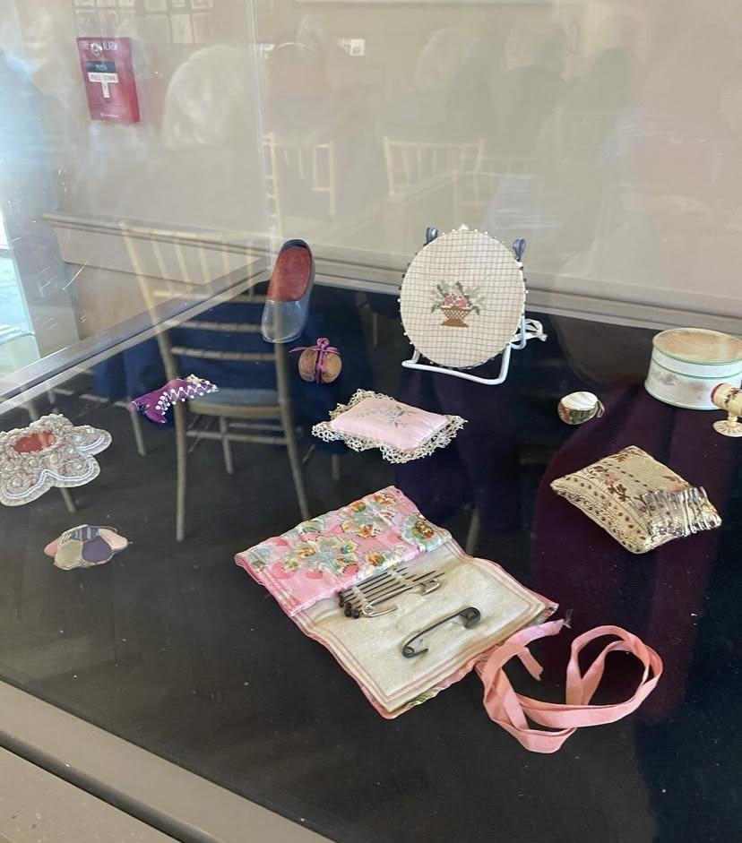
Pop-up exhibit of late nineteenth-century pincushions and sewing paraphernalia, photo courtesy of Locust Grove Estate.

Last spring, I took part in a Community-Engaged Learning opportunity through the History Department with Locust Grove Estate, a nonprofit organization that preserves the Locust Grove mansion and grounds, located about a ten-minute drive from the Vassar campus. Constructed in 1852 and originally owned by Samuel F. B. Morse (of Morse code fame), the mansion was later occupied by the Youngs, a wealthy local family, for eighty years. From when the Youngs moved to Locust Grove in 1895, their daughter Annette continuously occupied the house until 1975, and upon her passing founded the museum. The Youngs nearly obsessively saved everything from both their own estate and the earlier estate of their relatives across the Hudson, Locust Lawn, amassing a collection of antiques big and small that serves as a treasure trove for researchers today.

My role was as a curatorial intern focusing on historic fashion and material culture in the museum’s archives, working with selections from their approximately 15,000-piece art and textile collection. The collection includes everything ranging from hand-embroidered handkerchiefs to bolts of unused fabric to entire outfits from the 1830s through the 1910s. My job was to bring these pieces into the public view, engaging the community with artifacts in accessible ways. I worked on a variety of projects during my time there, including writing blog posts about pieces from the collection, constructing mini exhibits in the visitor center’s display cases, and even tasks outside of the scope of my internship, such as constructing a “fairy house” for an annual children’s program at the museum.

On one hand, my work at Locust Grove offered me an escape from my typical mid-semester routine. I looked forward to the two afternoons a week when I could get off-campus, even for a little while, and experience something new: looking through boxes in the chilly archives and finding a beautifully preserved dress, touring the mansion for the very first time and getting a behind-the-scenes look into the attic, or even just walking around in the garden as the flowers started to bloom in April. But on the other hand, I found a much deeper meaning in my experience. I got to bring the skills of historical interpretation I had learned in Swift and apply them to projects beyond the borders of the Vassar campus. For example, writing about something as small as a late-Victorian hand fan from the collection could reveal so much about globalization, commodity culture, and ideals of womanhood in the nineteenth century, and I cherished the opportunity to share these ideas with the community. At Locust Grove, knowing that my contributions would resonate beyond the classroom was very important to me and will stand as a highlight of my Vassar experience.

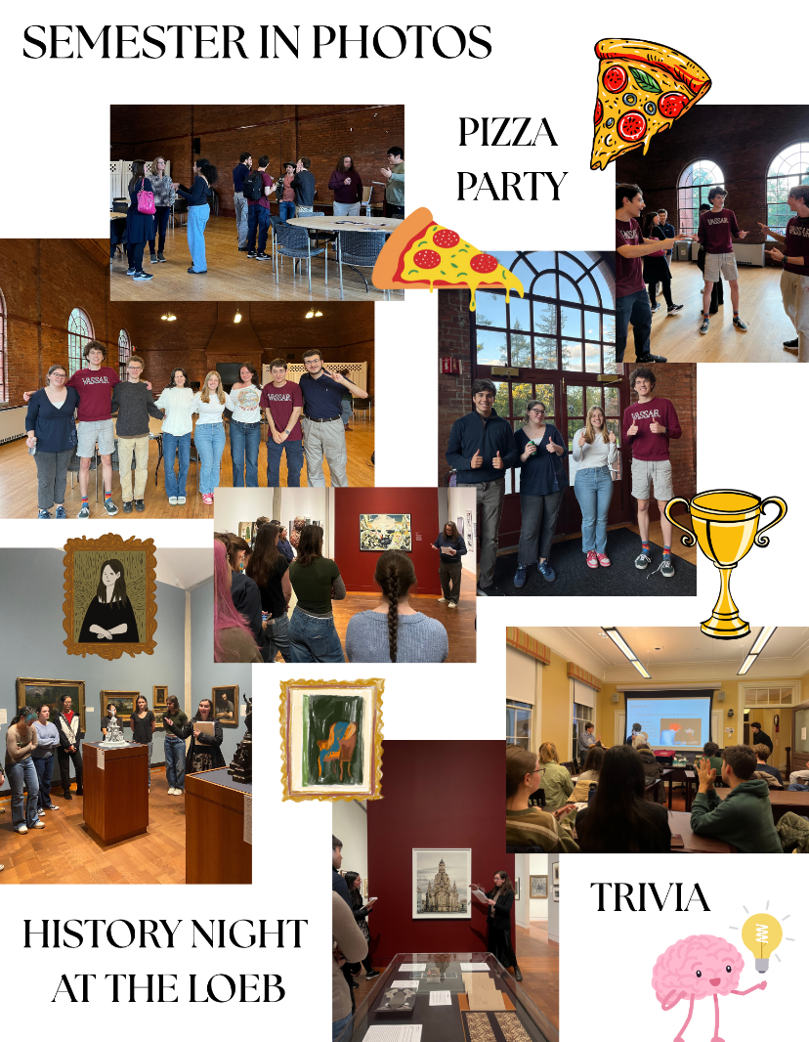
Designed by Natalie Buzzell ‘26

Spring 2026 History Department Courses

HIST-109: Becoming Taiwan (Professor Chang)
HIST-125: Infamy on Trial: Famous Trials in Early Modern Europe (Professor Choudhury)
HIST-164: Environmental History of Latin America (Professor Mendiola)

HIST-210: Dangerous Liaisons, Dangerous Selves (Professor Choudhury)
HIST-212: Indigeneity, Race, and Gender in the Native American South (Professor Smyth)
HIST-214: The Roots of the Palestine-Israel Conflict (Professor Schreier)
HIST-219: Deceptive Maps and Where to Find Them (Professor Chang)
HIST-224: Intersectionality in the Middle Ages and the Renaissance (Professor Choudhury)
HIST-227: Chinatowns (Professor Shih)
HIST-234: Fin-de-Siècle Vienna: Crisis, Politics, and Culture in a Modern City (Professor Solovy)
HIST-254: Victorian Britain (Professor Murdoch)
HIST-265: Cold War America (Professor Brigham)
HIST-272: Modern African History (Professor Rashid)
HIST-278: Women’s History of Latin America (Professor Mendiola)
HIST-287: Gender, Race, and Sexuality in Modern America (Professor Brennan)
HIST-288: Public Health and Social Welfare Policy in Modern America (Professor Brennan)

HIST-311: Trauma, Memory and Justice: Quests of Modern East Asia (Professor Chang)
HIST-314: History of Asian American Social Movements (Professor Shih)
HIST-360: Fascism in Twentieth Century Europe (Professor Solovy)
HIST-380: Ukraine/Russia: War and Peace (Professor Pohl)

